**Project 2**

Special Instructions to run the java files in Project 2:

* For **Part 1** of the project where we generate the private key, please run the file named as RSAGenKey.java
  + To run the file run the command:

**java RSAGenKey.java 6511 4733 8311**

* + After the above file is run successfully we will see the below output:



The below two files are created containing the public key and private key –

pri_key.txt:

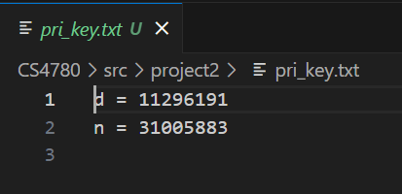

pub_key.txt:

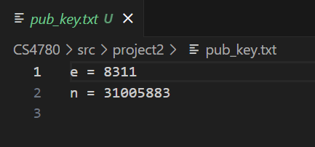

* For **Part 2** of the project where we encrypt the text.txt file containing the message using **RSA Encryption** **algorithm**, please run the file with named as RSAEncrypt.java
  + To run the file, run the command :

**java RSAEncrypt.java test.txt pub_key.txt**

* + After the above file is run successfully we will see the below output:



The below file is created with encrypted message – test.enc:

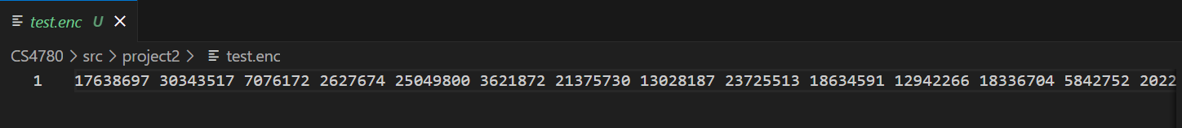

* For **Part 3** of the project where we decrypt the file having the encrypted plaintext, please run the file named as RSADecrypt.java
  + To run the file, run the command :

**java RSADecrypt.java test.enc pri_key.txt**

* + After the above file is run successfully we will see the below output:



The below file is created with decrypted message – test.dec



Submitted By:

Yash Kumar Jain

Yash Shah

Daniel Jimenez